National Apprenticeship Service

REGISTER WITH THE NATIONAL APPRENTICESHIP WEBSITE FOR LIVE UPDATES ON APPRENTICESHIPS IN THE AREA OF YOUR CHOICE – WITHIN 5 OR 10 MILES ETC OF YOUR POSTCODE
HOW TO REGISTER
- Log on to www.findapprenticeship.service.gov.uk and click on ‘create an account’
The page should look like this:

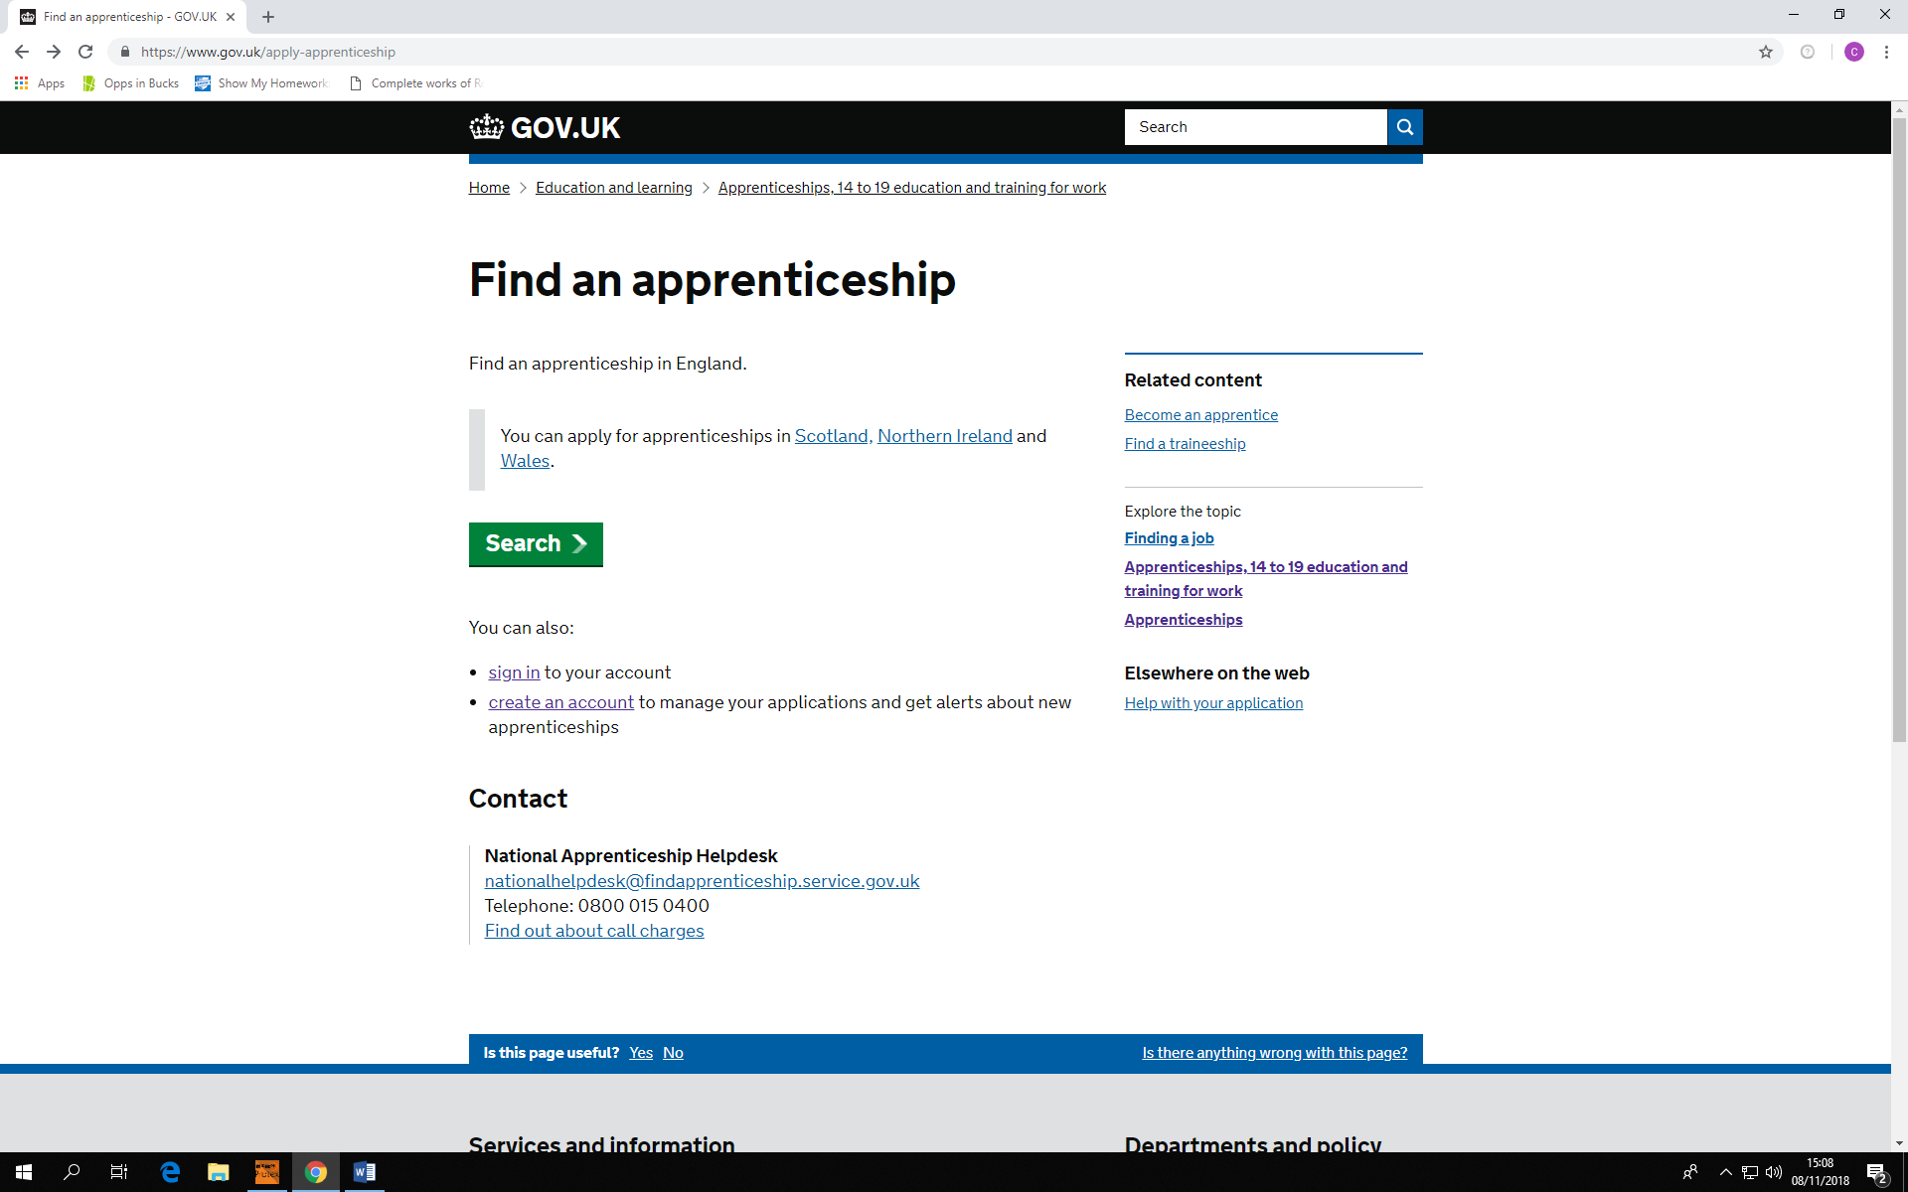

- This will take you to the registration page, simply fill this in
The page should look like this:

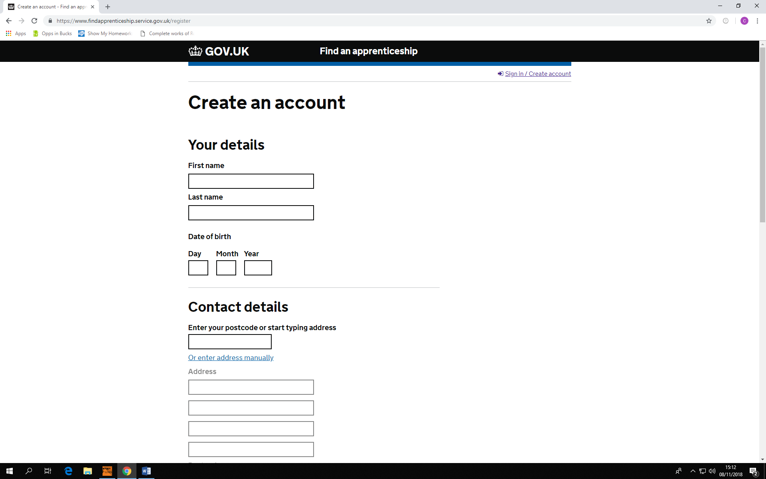

- You will be sent an account activation code by email
Enter this and you’re all set up to receive free updates on all Apprenticeship opportunities within your chosen area.

