Positive social media accounts to boost your mood

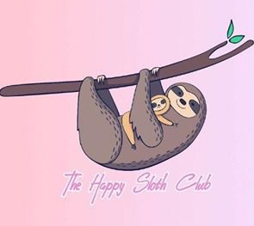 The Happy Sloth Club
https://www.instagram.com/thehappyslothclub/?hl=en
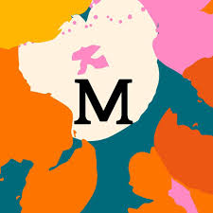 Mantra Magazine
https://www.instagram.com/mantramagazine/?hl=en
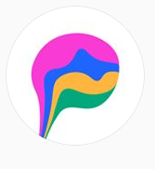 How Mental
https://www.instagram.com/howmental/?hl=en

Mental Health Foundation
https://www.instagram.com/mentalhealthfoundation/?hl=en
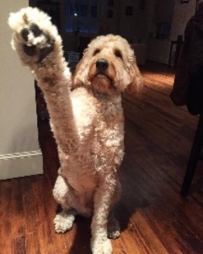 Paws Up
https://www.instagram.com/pawsup/?hl=en
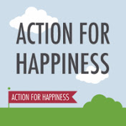 Action for Happiness
https://www.facebook.com/actionforhappiness/

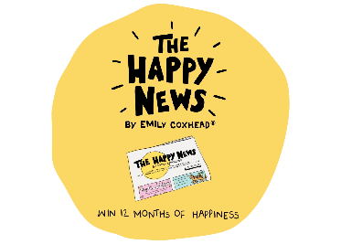 The Happy Newspaper The Power of Positivity
https://thehappynewspaper.com https://www.facebook.com/powerofpositivity/

